Part C Program 3

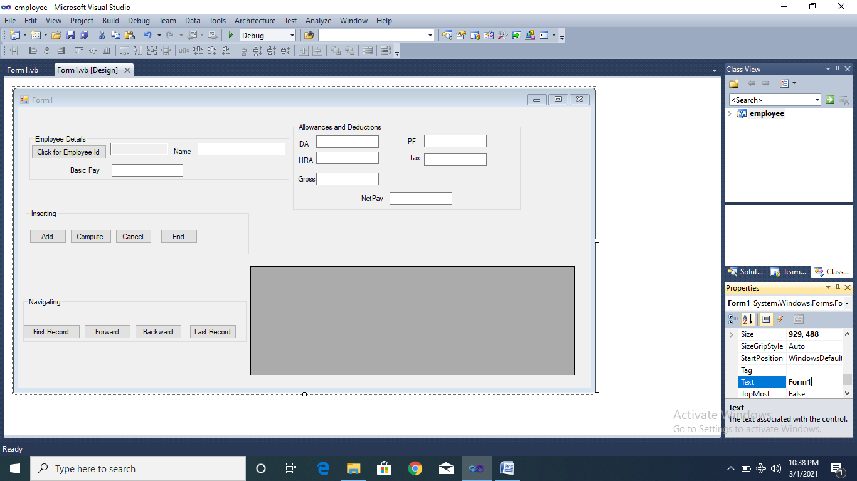

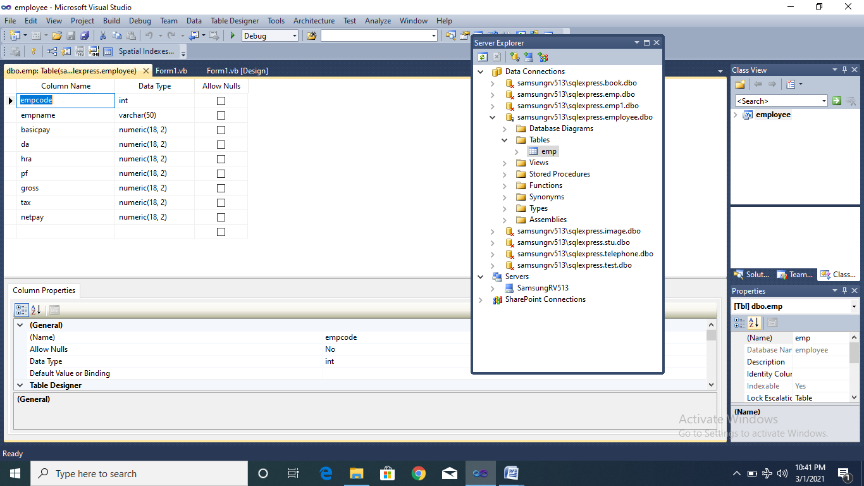

Imports System.Data.SqlClient

Module module1

Public con As New SqlConnection

Public cmd As New SqlCommand

Public Sub connect()

con.ConnectionString = "Data Source=SAMSUNGRV513\SQLEXPRESS;Initial Catalog=employee;Integrated Security=True;Pooling=False"

con.Open()

cmd.Connection = con

End Sub

End Module

Public Class Form1

Dim adp As SqlDataAdapter

Dim ds As DataSet

Public Sub autogenerate()

connect()

Dim num As Integer

cmd.CommandText = "select max(empcode) from emp"

If IsDBNull(cmd.ExecuteScalar) Then

num = 1001

Else

num = cmd.ExecuteScalar + 1

End If

TextBox1.Text = num

con.Close()

End Sub

Private Sub btnend_Click(ByVal sender As System.Object, ByVal e As System.EventArgs) Handles btnend.Click

End

End Sub

Private Sub Form1_Load(ByVal sender As System.Object, ByVal e As System.EventArgs) Handles MyBase.Load

GroupBox4.Visible = False

btnadd.Enabled = False

End Sub

Private Sub btnadd_Click(ByVal sender As System.Object, ByVal e As System.EventArgs) Handles btnadd.Click

connect()

cmd.CommandText = "insert into emp(empcode,empname,basicpay,da,hra,pf,gross,tax,netpay)values ('" & TextBox1.Text & "','" & TextBox2.Text & "','" & TextBox3.Text & "','" & TextBox4.Text & "','" & TextBox5.Text & "','" & TextBox6.Text & "','" & TextBox7.Text & "','" & TextBox8.Text & "','" & TextBox9.Text & "')"

cmd.ExecuteNonQuery()

MsgBox("Record inserted")

con.Close()

connect()

cmd.CommandText = "select * from emp"

adp = New SqlDataAdapter(cmd)

ds = New DataSet

adp.Fill(ds, "emp")

DataGridView1.DataMember = "emp"

DataGridView1.DataSource = ds

End Sub

Private Sub btncompute_Click(ByVal sender As System.Object, ByVal e As System.EventArgs) Handles btncompute.Click

Dim basicpay, da, hra, pf, gross, tax, netpay As Decimal

If TextBox1.Text = "" Or TextBox2.Text = "" Or TextBox3.Text = "" Then

MsgBox("Enter all the fields")

Exit Sub

End If

basicpay = Val(TextBox3.Text)

If basicpay < 0 Then

MsgBox("Basic pay should be positive number")

Exit Sub

End If

If basicpay > 20000 Then

da = basicpay * 0.04

Else

da = basicpay * 0.03

End If

hra = basicpay * 0.1

gross = basicpay + da + hra

pf = gross * 0.12

If pf > 780 Then

pf = 780

End If

tax = gross * 0.1

netpay = gross - (pf + tax)

GroupBox4.Visible = True

TextBox4.Text = da

TextBox5.Text = hra

TextBox6.Text = pf

TextBox7.Text = gross

TextBox8.Text = tax

TextBox9.Text = netpay

For Each tb As TextBox In GroupBox4.Controls.OfType(Of TextBox)()

tb.ReadOnly = True

Next

btnadd.Enabled = True

End Sub

Private Sub btnauto_Click(ByVal sender As System.Object, ByVal e As System.EventArgs) Handles btnauto.Click

autogenerate()

End Sub

Private Sub btnfirst_Click(ByVal sender As System.Object, ByVal e As System.EventArgs) Handles btnfirst.Click

BindingContext(ds, "emp").Position = 0

End Sub

Private Sub btnlast_Click(ByVal sender As System.Object, ByVal e As System.EventArgs) Handles btnlast.Click

BindingContext(ds, "emp").Position = BindingContext(ds, "emp").Count - 1

End Sub

Private Sub btnfor_Click(ByVal sender As System.Object, ByVal e As System.EventArgs) Handles btnfor.Click

If BindingContext(ds, "emp").Position = BindingContext(ds, "emp").Count - 1 Then

MsgBox("You are already in last record. Can't move further")

Else

BindingContext(ds, "emp").Position = BindingContext(ds, "emp").Position + 1

End If

End Sub

Private Sub btnback_Click(ByVal sender As System.Object, ByVal e As System.EventArgs) Handles btnback.Click

If BindingContext(ds, "emp").Position = 0 Then

MsgBox("You are already in first record")

Else

BindingContext(ds, "emp").Position = BindingContext(ds, "emp").Position - 1

End If

End Sub

Private Sub btncancel_Click(ByVal sender As System.Object, ByVal e As System.EventArgs) Handles btncancel.Click

TextBox1.Text = ""

TextBox2.Text = ""

TextBox3.Text = ""

GroupBox4.Visible = False

btnadd.Enabled = False

End Sub

End Class